1. **What is SDLC? Explain the different phases of SDLC. (May/June 2015, Nov/Dec 2014, May/June 2014, May/June 2013)**

**Methodology**

* The SDLC is a methodology for the design and implementation of an information system in an organization.
* A methodology is a formal approach to solving a problem based on a structured sequence of procedures.
* Using a methodology ensures a rigorous process and avoids missing those steps that can lead to compromising the end goal.
* The goal in this case is creating a comprehensive security posture.
* A methodology also increases the probability of success.
* Once a methodology has been adopted, the key milestones are established and a team of individuals is selected and made accountable to accomplish the project goals.

**SDLC Waterfall Methodology**

**Phases**

* The traditional SDLC consists of six general phases.
* The different variations of SDLC range from three to 12 stages, all of which have been mapped into the six presented here.
* Each of these stages come from the Waterfall model pictured in Figure, in which each phase begins with the results and information gained from the previous phase.

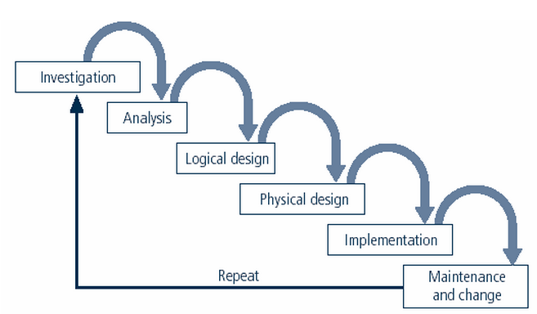

**SDLC Waterfall Methodology**

* In the **Investigation phase**
  + The process begins with an investigation of the problem facing the organization
  + Analysis of current organizational practices considered in the context of the investigation
* Then proceeds into the **logical and physical design phases**.
* During the **design phases** potential solutions are identified and are associated with evaluation criteria.
* In the **implementation phase**
* Solutions are evaluated
* Selected, and
* Acquired through a make-or-buy process.

These solutions, whether made or bought, are tested, installed, and tested again. Users of systems are trained and documentation developed.

* Finally, the system becomes mature and is **maintained** and modified over the remainder of its operational life.

**Investigation**

In the Investigation phase

* What is the problem the system is being developed to solve?
* The investigation phase begins with
* An examination of the event or
* Plan that initiates the process.
* During the investigation phase
* The objectives
* Constraints, and
* Scope of the project is specified.
* A preliminary cost benefit analysis is developed to evaluate the perceived benefits and the appropriate levels of cost for those benefits.
* At the conclusion of this stage a feasibility analysis is performed which
* Assesses the economic
* Technical and
* Behavioral feasibilities of the process and ensures that implementation is worth the organization’s time and effort.

**Analysis**

* The analysis phase begins with the information gained during the investigation phase.
* This phase consists
* Primarily of assessments of the organization,
* The status of current systems, and
* The capability to support the proposed systems.
* Analysts begin to determine
* What the new system is expected to do and
* How it will interact with existing systems.
  + - * This phase ends with the documentation of the findings and an update of the feasibility analysis.

**Logical Design**

* The information gained from the analysis phase is used to begin creating a solution

system for a business problem.

* In any systems solution, it is imperative that the first and driving factor is the business need.
* Then, based on the business need applications are selected that are capable of providing needed services.
* Based on the applications needed, **data support and structures** capable of providing the needed inputs are then chosen.
* Finally, based on all of the above, **specific technologies** to implement the physical solution are delineated.
* The logical design is, therefore, the **blueprint** for the desired solution.
* The logical design is implementation independent, meanings that it contains no reference to **specific technologies, vendors, or products**.

**Physical Design**

* The specific technologies are selected to support the alternatives identified and evaluated in the logical design.
* The selected components are evaluated based on a make-or-buy decision.
* Final designs integrate various components and technologies. After yet another feasibility analysis, the entire solution is presented to the organizational management for approval.

**Implementation**

* In the implementation phase
  + Any needed software is created
  + Components are ordered, received, and tested.
  + Afterwards users are trained and supporting documentation created.
  + Once all components are tested individually, they are installed and tested as systems.
* Again a feasibility analysis is prepared, and the sponsors are then presented with the system for a performance review and acceptance test.

**Maintenance and Change**

* The maintenance and change phase is the longest and most expensive phase of the process.
* This phase consists of
  + The tasks necessary to support and
  + Modify the system for the remainder of its useful life cycle.
    - Even though formal development may conclude during this phase, the life cycle of the project continues until it is determined that the process should begin again from the investigation phase.

**At periodic points**

* + The system is tested for compliance and the feasibility of continuance versus discontinuance is evaluated.
  + Upgrades, updates, and patches are managed.
  + As the needs of the organization change the systems that support the organization must also change.
* When the current system can no longer support the evolving mission of the organization, the project is terminated and a new project is implemented.